1. Frontend (Node.js with Express):
- Create a frontend using Express and Node.js.
- Include a form similar to the one from the Flask Assignment 2.
- Configure the form to send a request to the Flask backend.

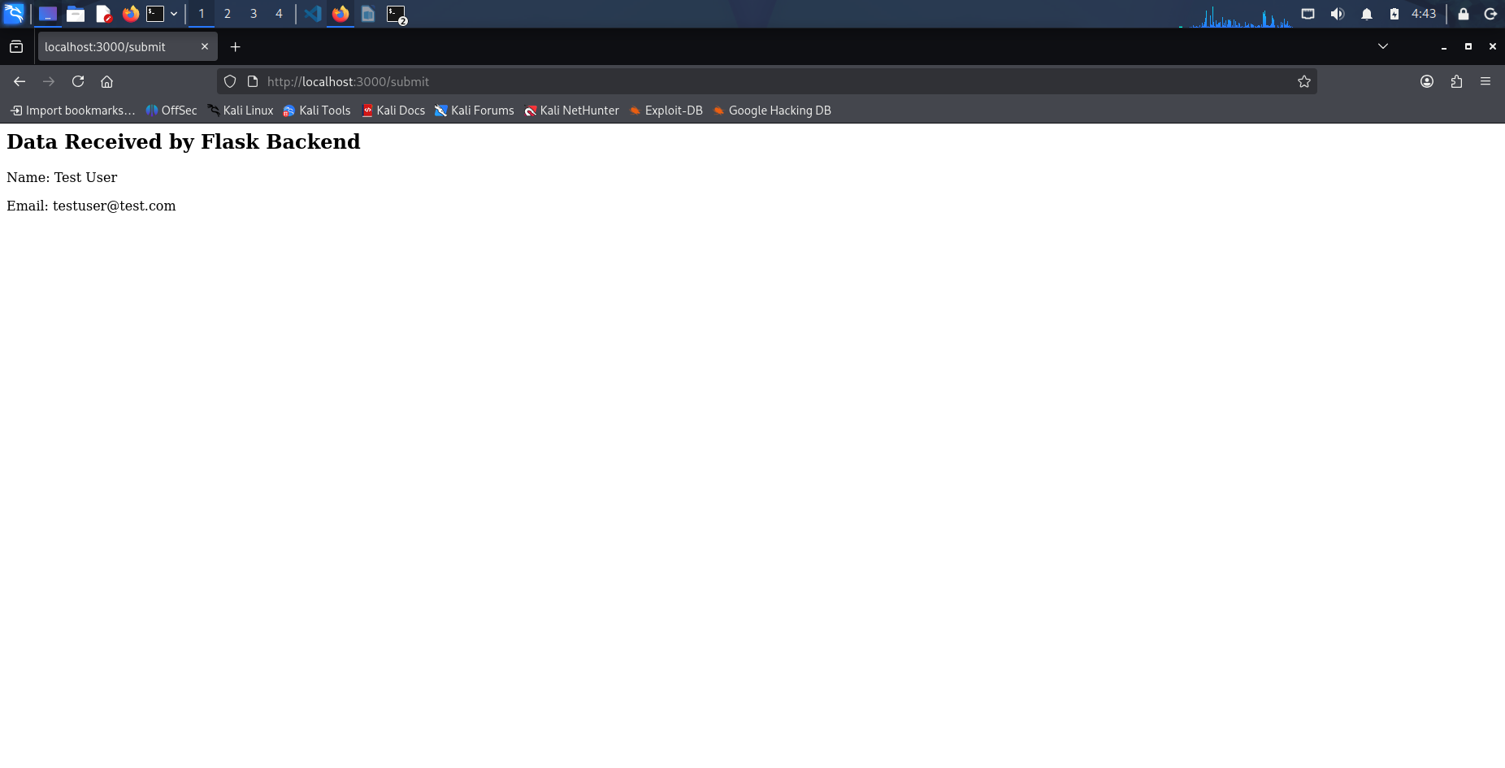

Backend (Flask):
- Use the Flask backend to handle the form submission and process the data.

- Folder Structure:
            - Organize the project with separate folders for the frontend and backend.

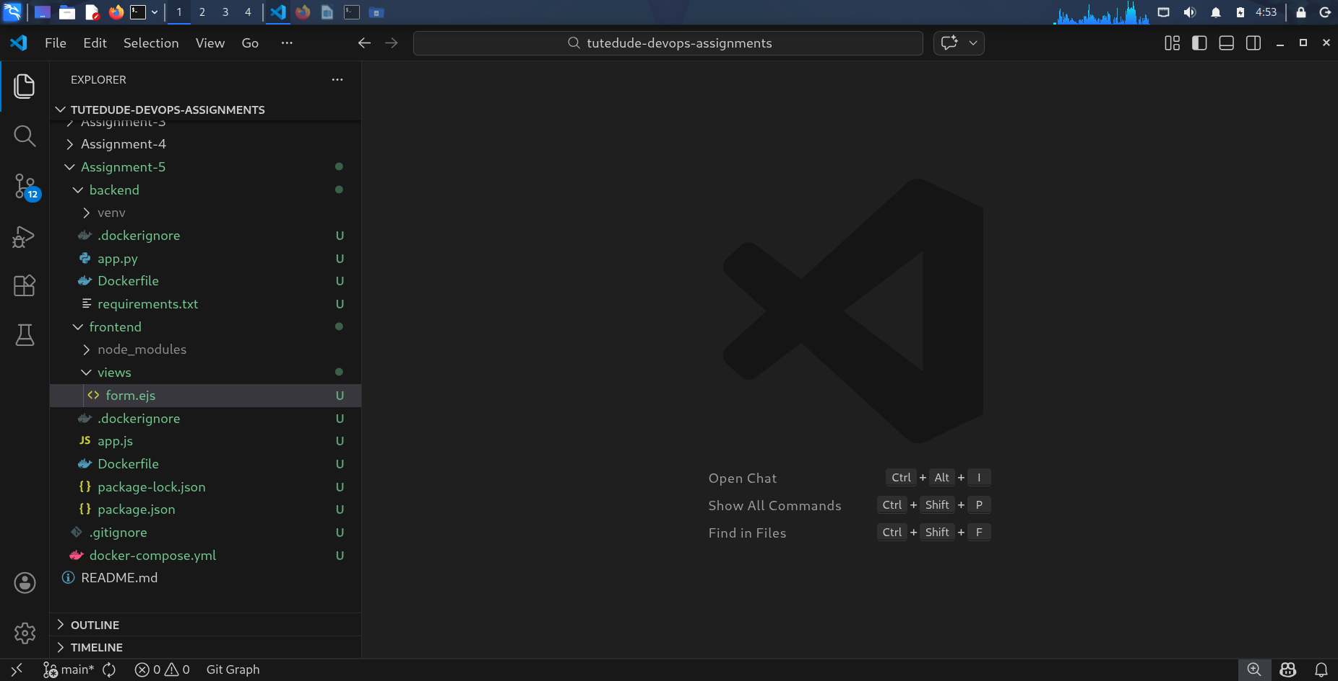

- Docker Configuration:
- Create a Dockerfile for both the frontend and backend.

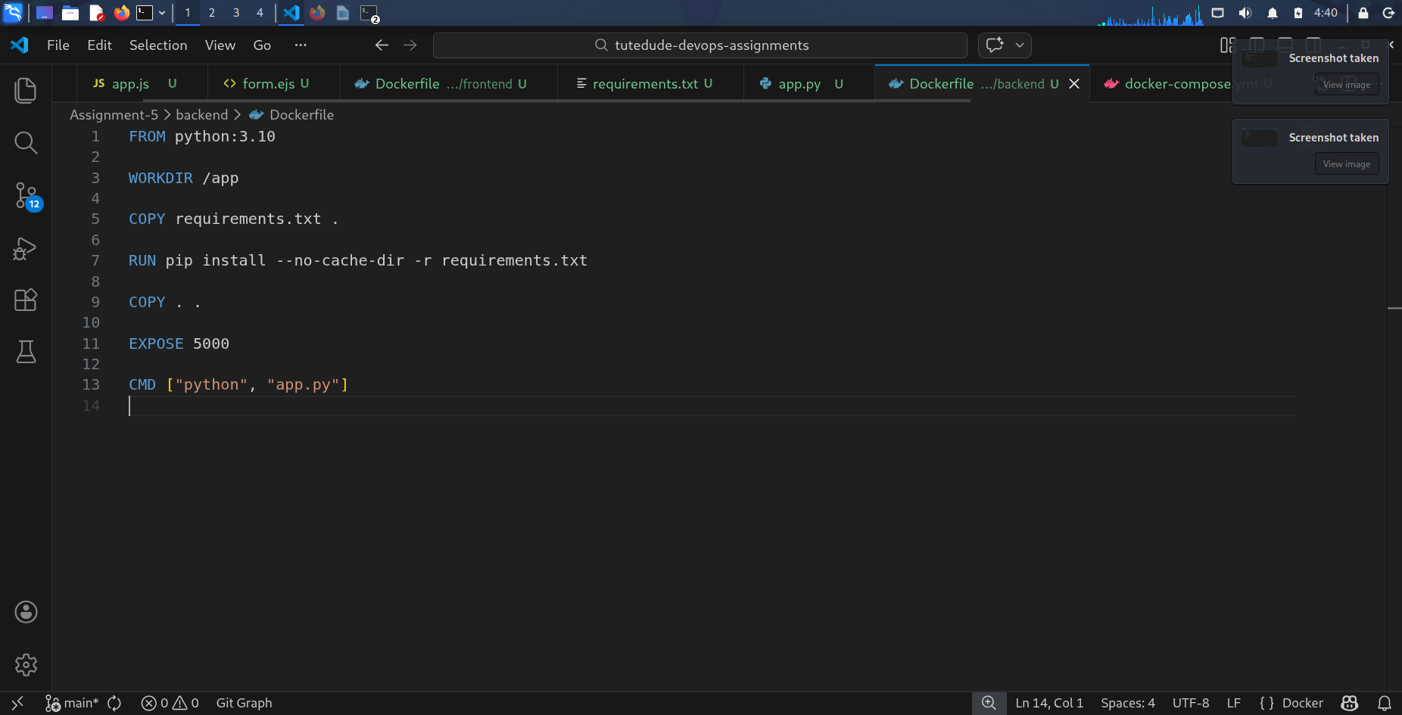

- Write a .yaml file (Docker Compose) to connect both services in the same network.

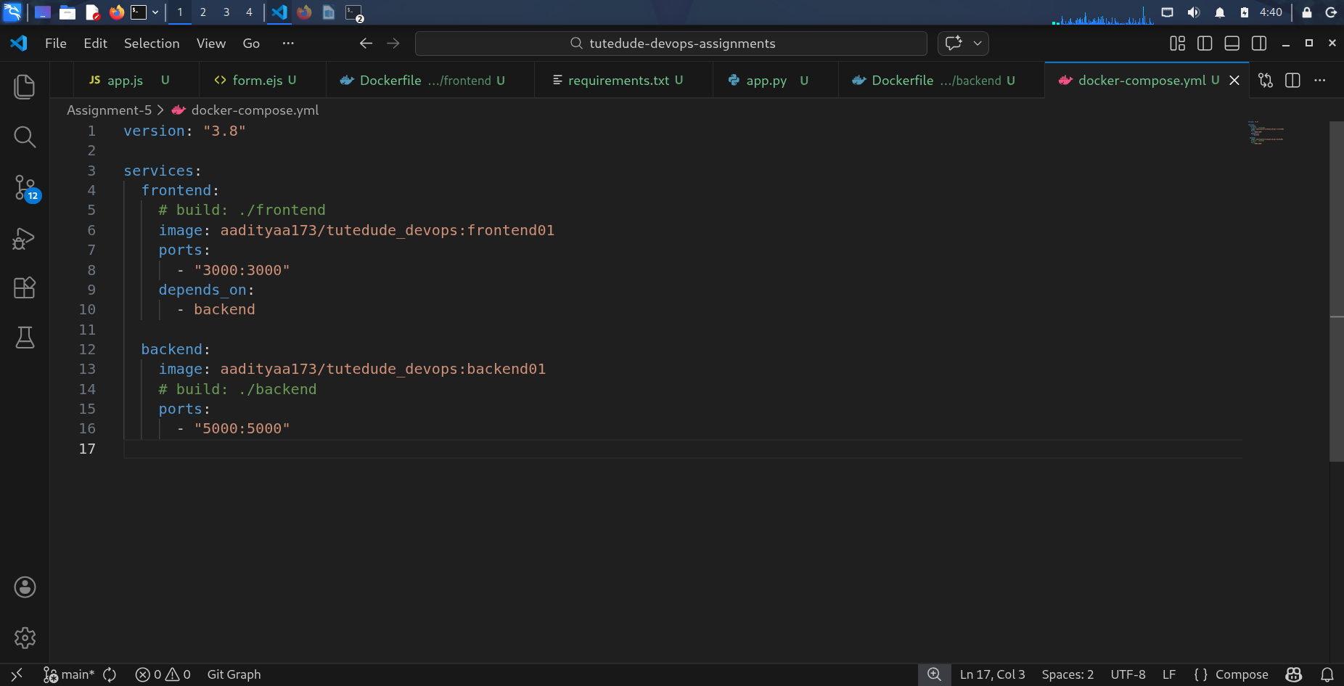

- Upload both images to docker hub and push your whole code to github and add the node_modules and other non required files(.vscode) in .gitignore
